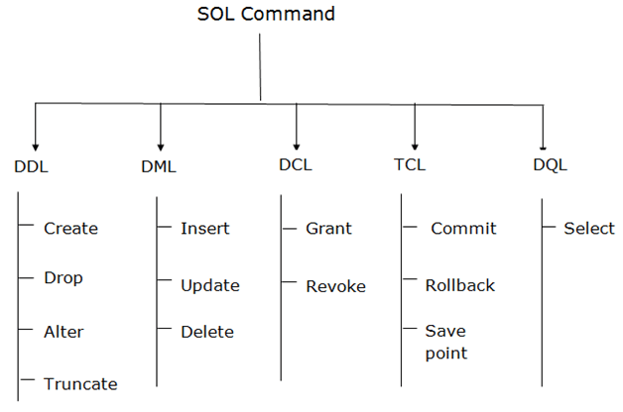

1 . DDL ( Data Definition Language ) :

* DDL Changes the Structure of The Table Like Creating a Table, Deleting A Table, Altering A Table, Etc.
* All The Command of DDL Are Auto-Committed That Means It Permanently Save All the Changes in The Database.
* DDL Commands :
* **CREATE**
* **ALTER**
* **DROP**
* **TRUNCATE**

**CREATE :** It is Used to Create a New Table in The Database.

**ALTER :** It is Used to Alter the Structure of The Database.

This Change Could Be Either to Modify the Characteristics of an Existing Attribute or Probably to Add a New Attribute

**DROP :** It is Used to Delete Both the Structure and Record Stored in the Table.

**TRUNCATE :** It is Used to Delete All the Rows from the Table and Free the Space Containing

in the Table.

2 . DML ( Data Manipulation Language ) :

* DML Commands are Used to Modify the Database. It is Responsible for all Form of Changes in The Database.
* The Command of DML is Not Auto-Committed That Means It Can't Permanently Save all the Changes in The Database. They Can Be Rollback.
* DML Commands :
* **INSERT**
* **UPDATE**
* **DELETE**

**INSERT :** This SQL query is used to Insert Data into the Row of a Table.

**UPDATE :** This SQL query is used to Update or Modify the value of a Column in the Table.

**DELETE :** This SQL query is Remove One or More Row from a Table.

**3. DCL ( Data Control Language ) :**

* DCL commands are used to Grant and Take back Authority from any Database User.
* DCL commands :
* **Grant**
* **Revoke**

**Grant :** This SQL query is used to Give User Access Privileges to a Database.

**Revoke :** This SQL query is used to Take Back Permissions from the User.

**4 . TCL ( Transaction Control Language ) :**

* TCL commands can only use with DML commands like INSERT, DELETE and UPDATE only.
* These Operations are Automatically committed in the Database that's why they cannot be used while Creating Tables or Dropping them.
* TCL commands :
* **COMMIT**
* **ROLLBACK**
* **SAVEPOINT**

**COMMIT :** This SQL query is used to Save all the Transactions to the Database.

**ROLLBACK :** This SQL query is used to Undo Transactions that have not already been saved

to the Database.

**SAVEPOINT :** This SQL query is used to Roll the Transaction back to a Certain point without

Rolling back the Entire Transaction.

**5. DQL ( Data Query Language ) :**

* DQL is used to Fetch the Data from the Database.
* It uses only one command :
* **SELECT**

**SELECT :** This is the Same as the Projection Operation of Relational Algebra.

It is used to select the Attribute based on the condition described by

WHERE clause.